

Data Technician

Name:
Course Date:
Table of contents
Day 1: Task 1 2
Day 1: Task 2 3
Day 2: Task 1 4
Day 3: Task 1 7
Day 3: Task 2 7
Day 4: Task 1: SQL Practical 9
Course Notes 14
Additional Resources 14
Additional Information 14

Day 1: Task 1

Please research and complete the below questions relating to key concepts of databases.

What is a primary key? | Unique identifier for a record in a table
How does this differ from a secondary key? | A secondary key is a key that is not selected as primary and is a way of filtering data. There can be multiple secondary keys in a table, but only one primary key.
How are primary and foreign keys related? | The foreign key is an entry in a table which is a primary key in another table. That identifies relationships between the tables.
Provide a real-world example of a one-to-one relationship | Individual- Employee ID
Provide a real-world example of a one-to-many relationship | Company - Employees
Provide a real-world example of a many-to-many relationship | Customers-Products

Day 1: Task 2

Please research and complete the below questions relating to key concepts of databases.

What is the difference between a relational and non-relational database? | Relational databases are suitable for structured data in tables. Non-relational databases are flexible and can be used for unstructured or rapidly changing data. They store information in one table.
What type of data would benefit off the non-relational model?  Why? | Social media content – up-to-date data in real time. Scalable and flexible.

Day 2: Task 1
You are a junior data analyst at Northwind Traders. Your manager has assigned you a series of real-world business tasks. For each scenario:
- Write an SQL query to solve the request. Write an SQL query to solve the request.
- Run the query in MySQL Workbench using the Northwind database.
- Paste your query in the box below each question as evidence of completion.

1.📘 Retrieve Full Customer Data
Your manager has asked you to export the full list of all customer details into a report.
➡️ Write a SQL query to retrieve all columns from the Customers table.
select *
from Customers;

2.📘 Customer Names and Cities for Marketing
A marketing analyst is targeting a campaign based on customer names and their cities.
➡️ Write a SQL query to retrieve only the CustomerName and City columns from the Customers table.
select CustomerName, City from Customers;

3. 📘 Unique Cities for Delivery Network Expansion
The logistics team wants to know all the different cities where customers are located (no duplicates).
➡️ Write a SQL query to retrieve distinct values from the City column in the Customers table.
select Distinct city
from customers;

4.📘 High-Value Products Report
The product manager wants to analyse products priced over £50.
➡️ Write a SQL query to retrieve all columns from the Products table where the Price is greater than 50.
Select * from Products
Where Price > 50;

5.📘 International Customers Targeting (USA & UK)
The marketing team is preparing campaigns for customers in the USA and UK.
➡️ Write a SQL query to retrieve all columns from the Customers table where the Country is either 'USA' or 'UK'.
Select * From Customers
Where Country = ‘USA’ or Country = ‘UK’;

6.📘 Recent Orders Report
Your team needs to analyze the latest orders.
➡️ Write a SQL query to retrieve all columns from the Orders table, sorted by OrderDate in descending order.
Select * From Orders
Order By OrderDate DESC;

7.📘 Mid-Range Products Listing
You are preparing a product list for items priced between £20 and £50.
➡️ Write a SQL query to retrieve all columns from the Products table where the Price is between 20 and 50, ordered by descending Price.
Select * From Products
Where Price Between 20 and 50
Order by Price Desc;

8.📘 Local Marketing in the US (Portland & Kirkland)
You’re focusing on customers from Portland and Kirkland in the USA.
➡️ Write a SQL query to retrieve all columns from the Customers table where the Country is 'USA' and City is either 'Portland' or 'Kirkland', ordered by ascending CustomerName.
select * from Customers
where city = "Portland" or city = "Kirkland";

9. 📘 Customers from the UK or London
Prepare a list for promotional emails targeting customers from the UK or those based in London.
➡️ Write a SQL query to retrieve all columns from the Customers table where the Country is 'UK' or City is 'London', ordered by descending CustomerName.
Select * From Customers
Where Country = ‘UK’ and City = 'London’
Order by CustomerName Desc;

10.📘 Product Inventory for Selected Categories
The inventory team needs products from Category 1 or 2, sorted alphabetically.
➡️ Write a SQL query to retrieve all columns from the Products table where the CategoryID is 1 or 2, ordered by ascending ProductName.
Select * From Products
Where CategoryID in (1,2)
Order by ProductName ASC;

Day 3: Task 1

Please research the below ‘JOIN’ types, explain what they are and provide an example of the types of data it would be used on.

Self-join | Used when the table needs to compare rows within the same table.
Right join | returns all records from the right table (table2), and the matching records from the left table (table1)
Full join | retrieves all records from both tables, including matching and non-matching records
Inner join | Returns only matching records
Cross join | Returns all row combinations in both tables.
Left join | combines rows from two tables, returning all rows from the right table and matching rows from the left table. If no match exists – a null is displayed

Day 3: Task 2
You are a junior data analyst at Northwind Traders. Your manager has assigned you a series of real-world business tasks. For each scenario:
- Write an SQL query to solve the request. Write an SQL query to solve the request.
- Run the query in MySQL Workbench using the Northwind database.
- Paste your query in the box below each question as evidence of completion.

1.📘 Linking Products to Suppliers
Management wants to know which supplier provides each product in the inventory.
➡️ Write a SQL query to find the supplier of each product.
Select supplierName, productName
from suppliers
join products
on suppliers.SupplierID = products.SupplierID
Order by SupplierName asc;

2. 📘 Classifying Products by Category
The category manager is reviewing how products are organized.
➡️ Write a SQL query to find the category of each product.
Select categoryName, productName
from categories
join products
on categories.categoryID = products.CategoryID
Order by ProductName asc;

3.📘 Category-Specific Product Report: Meat/Poultry
The food department wants to view all items in the Meat/Poultry category.
➡️ Write a SQL query to retrieve all products belonging to the Meat/Poultry category.
Select CategoryName, productName
from categories
join products
on categories.categoryID = products.CategoryID
Where CategoryName = 'Meat/Poultry';

4.📘 Complete Order Overview
The business team wants to see a detailed order list with customer and employee information.
➡️ Write a SQL query to retrieve the Order ID, Order Date, Customer Name, and Employee Name for all orders.
Select orderID, orderdate, CustomerName, FirstName, Lastname
from orders
join employees
on orders.EmployeeID = employees.EmployeeID
join customers
on customers.CustomerID = orders.CustomerID;

5.📘 Supply Chain Overview Report
Your manager wants to see the product name, its category, and the name of its supplier all in one report.
➡️ Write a SQL query to retrieve the Product Name, Category Name, and Supplier Name for all products.
Select productname, categoryname, suppliername
from products
join categories
on products.CategoryID = Categories.categoryid
join suppliers
on suppliers.supplierid = products.SupplierID;

6.📘 Yearly Order Summary – 1996
The team is auditing customer orders made in 1996.
➡️ Write a SQL query to create a report for all the orders of 1996 and their customers.
SELECT o.orderid AS Order_ID, o.orderdate AS Order_Date, c.customername AS Customer
FROM orders AS o
INNER JOIN customers AS c
ON o.customerid = c.customerid
WHERE o.orderdate LIKE '%1996%';

7.📘 Product Count by Category
The product team wants to know how many products exist under each category.
➡️ Write a SQL query to retrieve all categories along with the number of products in each category.
select categoryname, count(productid) as prod
from products as p
join categories as c
on p.categoryid = c.categoryid
group by categoryname
order by prod desc;

8.📘 Sales Volume Breakdown
The sales department wants to analyze how much of each product was ordered and at what price.
➡️ Write a SQL query to retrieve all products with their prices and the quantity ordered for each product.
SELECT
p.ProductName,
p.Price,
SUM(od.Quantity) AS TotalQuantityOrdered
FROM
Products as p
LEFT JOIN
Order_Details od ON p.ProductID = od.ProductID
GROUP BY
p.ProductID, p.ProductName, p.Price
ORDER BY
p.ProductName;

Day 4: Task 1: SQL Practical

You are working as a junior data analyst for an international research organization analyzing countries, cities, and languages from around the world. Your job is to write and run SQL queries that provide useful global insights.
For each task:
- Write the appropriate SQL query to meet the scenario's objective.
- Run your query using MySQL Workbench and the world database.
- Take a screenshot that clearly shows both your SQL code and the result table.
- Paste the screenshot in the box provided for each question as evidence of completion.
Setting up the database:

- Download world_db here
- Follow each step to create your database here

- Count Cities in USA: Scenario: You've been tasked with conducting a demographic analysis of cities in the United States. Your first step is to determine the total number of cities within the country to provide a baseline for further analysis.

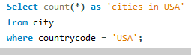

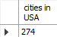

- Country with Highest Life Expectancy: Scenario: As part of a global health initiative, you've been assigned to identify the country with the highest life expectancy. This information will be crucial for prioritising healthcare resources and interventions.

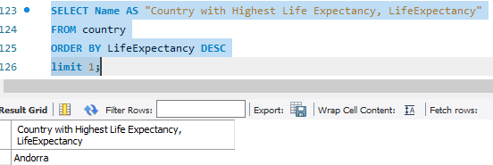

- "New Year Promotion: Featuring Cities with 'New : Scenario: In anticipation of the upcoming New Year, your travel agency is gearing up for a special promotion featuring cities with names including the word 'New'. You're tasked with swiftly compiling a list of all cities from around the world. This curated selection will be essential in creating promotional materials and enticing travellers with exciting destinations to kick off the New Year in style.
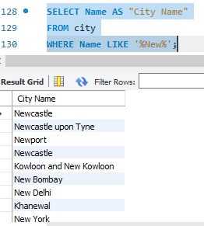

- Display Columns with Limit (First 10 Rows): Scenario: You're tasked with providing a brief overview of the most populous cities in the world. To keep the report concise, you're instructed to list only the first 10 cities by population from the database.
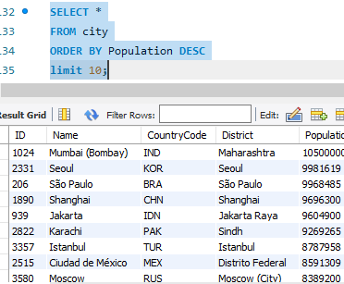

- Cities with Population Larger than 2,000,000: Scenario: A real estate developer is interested in cities with substantial population sizes for potential investment opportunities. You're tasked with identifying cities from the database with populations exceeding 2 million to focus their research efforts.

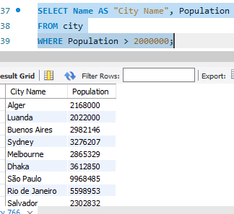

- Cities Beginning with 'Be' Prefix: Scenario: A travel blogger is planning a series of articles featuring cities with unique names. You're tasked with compiling a list of cities from the database that start with the prefix 'Be' to assist in the blogger's content creation process.
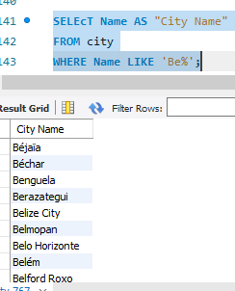

- Cities with Population Between 500,000-1,000,000: Scenario: An urban planning committee needs to identify mid-sized cities suitable for infrastructure development projects. You're tasked with identifying cities with populations ranging between 500,000 and 1 million to inform their decision-making process.
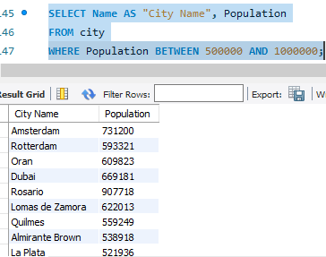

- Display Cities Sorted by Name in Ascending Order: Scenario: A geography teacher is preparing a lesson on alphabetical order using city names. You're tasked with providing a sorted list of cities from the database in ascending order by name to support the lesson plan.
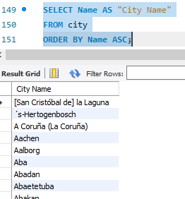

- Most Populated City: Scenario: A real estate investment firm is interested in cities with significant population densities for potential development projects. You're tasked with identifying the most populated city from the database to guide their investment decisions and strategic planning.
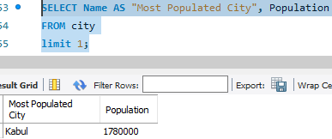

- City Name Frequency Analysis: Supporting Geography Education Scenario: In a geography class, students are learning about the distribution of city names around the world. The teacher, in preparation for a lesson on city name frequencies, wants to provide students with a list of unique city names sorted alphabetically, along with their respective counts of occurrences in the database. You're tasked with this sorted list to support the geography teacher.
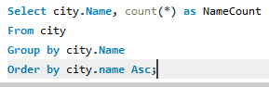
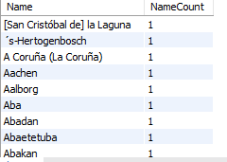

- City with the Lowest Population: Scenario: A census bureau is conducting an analysis of urban population distribution. You're tasked with identifying the city with the lowest population from the database to provide a comprehensive overview of demographic trends.
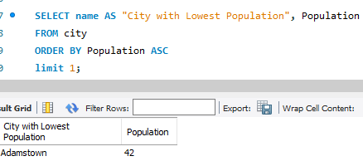

- Country with Largest Population: Scenario: A global economic research institute requires data on countries with the largest populations for a comprehensive analysis. You're tasked with identifying the country with the highest population from the database to provide valuable insights into demographic trends.
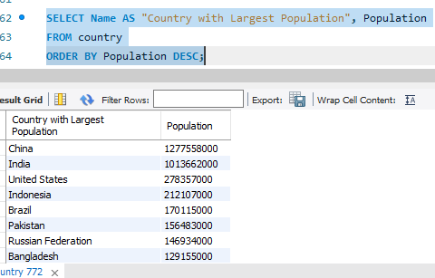

- Capital of Spain: Scenario: A travel agency is organising tours across Europe and needs accurate information on capital cities. You're tasked with identifying the capital of Spain from the database to ensure itinerary accuracy and provide travellers with essential destination information.
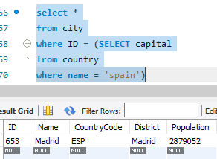

- Cities in Europe: Scenario: A European cultural exchange program is seeking to connect students with cities across the continent. You're tasked with compiling a list of cities located in Europe from the database to facilitate program planning and student engagement.
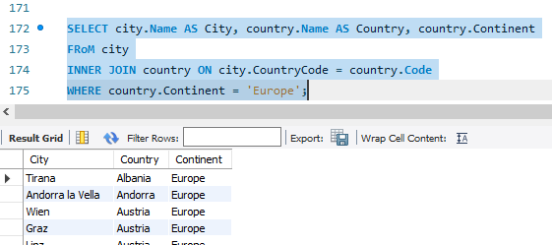

- Average Population by Country: Scenario: A demographic research team is conducting a comparative analysis of population distributions across countries. You're tasked with calculating the average population for each country from the database to provide valuable insights into global population trends.
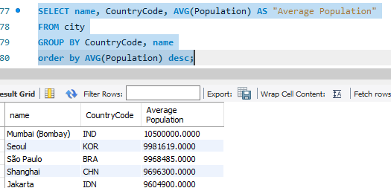

- Capital Cities Population Comparison: Scenario: A statistical analysis firm is examining population distributions between capital cities worldwide. You're tasked with comparing the populations of capital cities from different countries to identify trends and patterns in urban demographics.
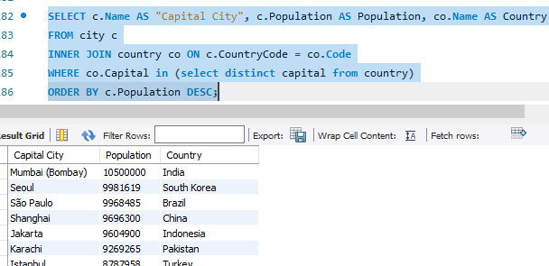

- Countries with Low Population Density: Scenario: An agricultural research institute is studying countries with low population densities for potential agricultural development projects. You're tasked with identifying countries with sparse populations from the database to support the institute's research efforts.
Select Name, Population, SurfaceArea, (Population/SurfaceArea) as Population_Density
from country
Where (Population/SurfaceArea)>0
order by Population_Density Asc;
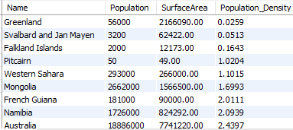

- Cities with High GDP per Capita: Scenario: An economic consulting firm is analysing cities with high GDP per capita for investment opportunities. You're tasked with identifying cities with above-average GDP per capita from the database to assist the firm in identifying potential investment destinations.
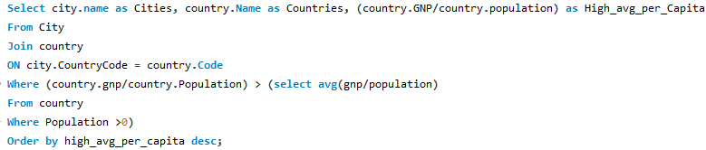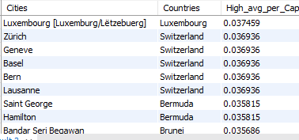

- Display Columns with Limit (Rows 31-40): Scenario: A market research firm requires detailed information on cities beyond the top rankings for a comprehensive analysis. You're tasked with providing data on cities ranked between 31st and 40th by population to ensure a thorough understanding of urban demographics.
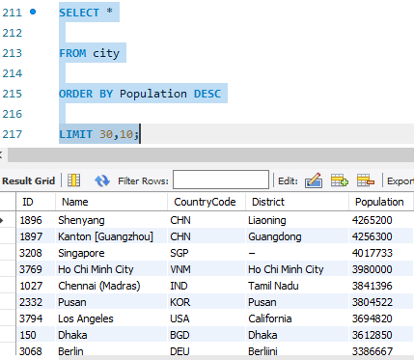

Course Notes

It is recommended to take notes from the course, use the space below to do so, or use the revision guide shared with the class:

Additional Resources
- SQLBolt - Learn SQL - Introduction to SQL : Welcome to SQLBolt, a series of interactive lessons and exercises designed to help you quickly learn SQL right in your browser.
- MySQL Basics Tutorial Series - YouTube: MySQL Basics Tutorial Series
- Hackerrank Challenges: How to use hackerrank challanges.odt
- Sakila DB Exercises:
  - Use this file to create the schema: create sakila db.sql
  - Access exercises here: sakila db exercises combined.sql
You can watch the video on how to open sql file:How to create a schema in workbench.webm

Additional Information

We have included a range of additional links to further resources and information that you may find useful, these can be found within your revision guide.

END OF WORKBOOK

Please check through your work thoroughly before submitting and update the table of contents if required.

Please send your completed work booklet to your trainer.

